BACK PAIN ON 2 SIDES OF A4
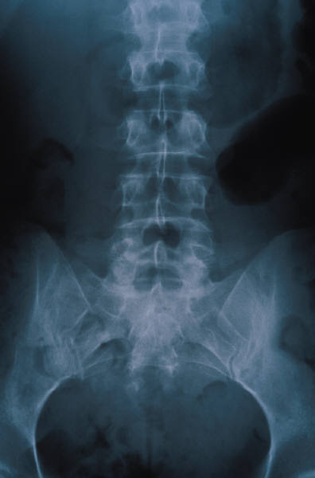
Epidemiology:
150 000 000 working days per year lost in UK
4-fold increase in 20 years but no change in the incidence of back pain
costs UK £6 billion per year
peak incidence 45-60 years
manual workers, smokers, social class 4 and 5 most affected
obesity and tallness associated, posture is not
Aetiology:
Mechanical strains predominate. Need to exclude spinal stenosis, neoplasms, metabolic bone disease, disc problems. Principal risk factor is previous history of back pain.
Simple Back Ache:
onset age 20-55
lumbo-sacral pain, not spreading beyond thigh
mechanical in nature
patient well
90% recover within first 6 weeks

Nerve Root Pain:
unilateral leg pain worse than back pain
pain to foot or toes
numbness and paraesthesia in same distribution
signs of nerve irritation, reduced straight leg raising
motor, sensory or reflex change limited to one nerve root
50% recover in 6 weeks
Emergency Referral:
difficulty with micturition
loss of sphincter tone or faecal incontinence
saddle anaesthesia about anus, perineum, genitalia
widespread (more than 1 nerve root) pr progressive motor weakness in legs or disturbed gait
Prognosis:
Most off for a few days, 90% are back in work in 6 weeks. Of those still off after 1 year, only 25% will return to employment. Of those still off at 2 years, only 10% will ever return to employment.
Danger Signs:
age <20 or >55
violent trauma
constant, progressive, non-mechanical pain
thoracic pain
past history of malignancy
use of systemic steroids
misuse of drugs or HIV infection
systemically unwell
weight loss
persisting severe restriction of lumbar flexion
widespread neurological signs
structural deformity
Tutorial prepared by Dr P Harrop, Riversdale Surgery, Bridgend 20 March 2002

